Centre for Professional Development & Lifelong Learning, School of Pharmacy

Application Form
To Study Individual Modules as Short Courses or Part of Another Programme
Please return your completed application and Equal Opportunities Monitoring form to the relevant
Programme Co-ordinator/Administrator depending upon your area of practice:

You will be advised of method of payment once your application has been accepted.

Module Costs:
10 credit module - £480.00
15 credit module - £720.00
30 credit module - £1,290.00
60 credit combination £2,570.00

Hospital Sector
Mrs Bev Oakden, Postgraduate Programmes Co-ordinator, School of Pharmacy, Keele University, Staffs ST5 5BG or e-mail b.oakden@keele.ac.uk

Primary Care Sector
Ms Amanda Salt, Postgraduate Programmes Administrator, School of Pharmacy, Keele University, Staffs ST5 5BG or e-mail a.salt@keele.ac.uk

NB: no course materials will be dispatched until the course fee has been paid.

Figure 1: Module Options for Clinical Pharmacy Practice Programme.

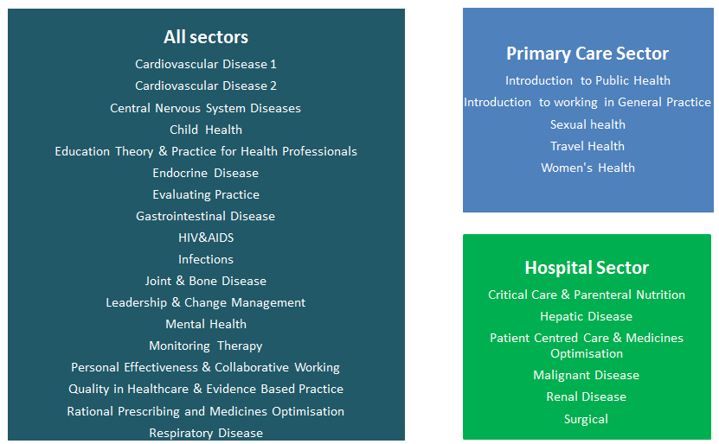

Please note that you may also choose to study the Independent Prescribing module (60 credits) as part of your diploma award.

Table 1: Clinical Pharmacy Practice Module availability

Module Title | Credit rating available | Quarter 1 | Quarter 2 | Quarter 3 | Quarter 4
 |  | Jan-March | Apr-  Jun | July-Sept | Oct-Dec
Cardiovascular Disease 1 | 10, 15, 30 |  |  |  | N/A
Cardiovascular Disease 2 | 10, 15, 30 | N/A
Central Nervous System Diseases | 10, 15, 30 | N/A
Child Health | 10, 15, 30 |  |  | N/A
Education Theory & Practice* | 10, 15, 30 | N/A |  | N/A | N/A
Endocrine Disease | 10, 15, 30 |  |  |  | N/A
Evaluating Practice | 10 |  | N/A
Gastrointestinal Disease | 10, 15, 30 | N/A
HIV & AIDS | 10, 15, 30 |  | N/A
Infections | 10, 15, 30 |  |  |  | N/A
Joint & Bone Disease | 10, 15, 30 | N/A | N/A
Leadership & Change Management | 10 | N/A | N/A
Mental Health | 10, 15, 30 |  | N/A
Monitoring Therapy | 10, 15, 30 |  |  |  | N/A
Personal Effectiveness & Collaborative Working | 10 |  |  |  | N/A
Quality in Healthcare and Evidence Based Practice | 10 |  | N/A | N/A
Rational Prescribing and Medicines Optimisation | 10 |  | N/A
Respiratory Disease | 10, 15, 30 | N/A
Introduction to Public Health | 10, 15, 30 | N/A
Introduction to Working in General Practice | 10, 15 | N/A
Sexual Health | 10,15, 30 |  |  |  | N/A
Travel Health | 10,15, 30 |  |  |  | N/A
Women's Health | 10,15, 30 |  |  | N/A
Critical Care and Parenteral Nutrition | 10, 15, 30 |  | N/A
Hepatic Disease | 10, 15, 30 | N/A
Malignant Disease | 10, 15, 30 |  | N/A
Patient Centred Care & Medicines Optimisation | 10, 15, 30 |  |  |  | N/A
Renal Disease | 10, 15, 30 |  |  |  | N/A
Surgical | 10, 15, 30 | N/A
N/A - not available to start during this quarter

*This module is only available to start in April as it has two face to face study days in May.

Please note that the module availability is subject to change and your module choices will be confirmed with you following application. Should you require any further information please contact us.

PART A

Course Details

Funding: Self-funding Funded by employer

If you are being sponsored then written confirmation from your sponsor needs to accompany your application form

Sector of Practice

Hospital (with inpatient responsibility) Hospital (outsource outpatient)

Working in a GP Practice Community Pharmacy

Other (please state) _____________________________________________

Please complete the following table with the module(s) you wish to apply for. Please indicate the credit rating you wish to study each module at as well as the month you wish to start the module.

Module Number | Module Title | Credit rating | Month you wish to start*
1
2
3
4
5
6
* Please note that all modules are released on the first Monday of each month. In order to start a module within a given month we must have received your fully completed application form and supporting documents by the 15th day of the previous month.

PART B

Personal Details

First Name(s) |  | Surname/Family Name:
Title: | Gender: | Date of Birth:
Contact Address:  Postcode:  Country: |  | Telephone:
 |  | Email:
 |  | Nationality:
 |  | Country of Birth:
 |  | Country of Residence:
Keele Student No.
(only applicable if previously studied at Keele)

PLEASE EXPAND THE BOXES BELOW AS NECESSARY TO PROVIDE THE DETAILS REQUESTED

Academic and professional qualifications. Please include academic institution, degree classification and year attended. NB PLEASE SEND A COPY OF YOUR DEGREE CERTIFICATE WITH YOUR APPLICATION FORM

Details of professional registration body and personal registration number:

Current Employment. Please include your job title/role, employer’s name, address and date employment started. NB PLEASE SEND AN EMPLOYER'S REFERENCE WITH YOUR APPLICATION FORM

If module(s) is/are undertaken as part of another Programme please state

Institution | Course and Course Number | Start Date | End Date

Briefly state reason for choosing module(s)

Data Protection Act
The information contained in this form will be used for the purpose of processing your application and, if your application is successful, will form the basis of your University record.

University Charter, Statute, Ordinances and Regulations
Registration at Keele University is conditional upon observation of the University’s Charter, Statute, Ordinances and Regulations in effect at any time. A copy of the current version may be obtained from the University Secretary’s office or is available on the web at www.keele.ac.uk/depts/vc/plansec/regs/reglist.htm

PLEASE ENSURE THAT YOUR APPLICATION IS COMPLETE AND RETURN TOGETHER WITH A COPY OF YOUR DEGREE CERTIFICATE AND A REFERENCE FROM YOUR EMPLOYER.

I hereby apply for admission to study at Keele University for the course set out above and confirm that the information provided is correct to the best of my knowledge.

Signature: Date:

Clinical Pharmacy Practice Programme
Declaration of Support from the Student’s Workplace

Note for the workplace

The Clinical Pharmacy Practice Programme has been developed for practising pharmacists. The course learning materials, activities and assessments are designed to relate to actual pharmacy practice to make the student’s learning experience more meaningful to their own environment. As well as reflecting on their practice in relation to their own patients, students may require access to other data and need the support in their workplace to access this information. Students are advised that all information they use to help them complete their coursework should remain confidential and that no patients, prescribers, or other individuals should be named.

Prospective students must arrange for this Declaration Form to be completed by an appropriate person e.g. Line Manager, Superintendent Pharmacist or GP/Practice Manager and submit it with their course application.

Please complete the details below in BLOCK print.

Student’s Name: ……………………………………………………………………………………………………

Name of Supporter: ………………………………………………………………………………………………..

Supporter’s Organisation/Address: …..…………………………………………………………………………..

………………………………………………………………………………………………………………………...

…………………………………………………………………………………………………………………………

Telephone: ………………………………………….. Email address: ……………………………………………

Supporter’s Position in the Organisation: …………………………………………………………………………

I agree to provide the support outlined above required to enable the above named student to complete their coursework for the Clinical Pharmacy Practice Programme

Signature: ……………………………………………………………… Date: ……………………………

PLEASE ENSURE THAT THIS APPLICATION FORM IS COMPLETED AND RETURNED WITH A COPY OF YOUR DEGREE CERTIFICATE AND A REFERENCE FROM YOUR CURRENT EMPLOYER.

KEELE UNIVERSITY

EQUAL OPPORTUNITIES MONITORING

Please help us to make our Equal Opportunities Policy effective by ticking the boxes applicable to you.

ETHNICITY

11 White-British 12 White-Irish

13 White-Scottish 14 Irish Traveller

19 Other White background 21 Black or Black British-Caribbean

22 Black or Black British-African 29 Other Black background

31 Asian or Asian British-Indian 32 Asian or Asian British-Pakistani

33 Asian or Asian British-Bangladeshi 34 Chinese Ethnic background

39 Other Asian background 41 Mixed-White and Black Caribbean

42 Mixed-White and Black African 43 Mixed-White and Asian

49 Other Mixed background 80 Other Ethnic background

90 Not known 98 Information refused

DISABILITIES

The University welcomes applications from people with disabilities and considers them on the same academic grounds as those from other candidates. If you indicate on this form that you have a disability, and if we make you an offer of a place, we will then inform our Disability Services Department who will contact you to discuss your support needs.

00 No known disability

If you have a disability, please indicate those which are applicable to you.

01 Dyslexia 02 Blind/ partially sighted

03 Deaf/ hearing impaired 04 Wheelchair user/ mobility difficulties

05 Personal care support 06 Mental health difficulties

07 An unseen disability e.g. diabetes, 08 Multiple disabilities
epilepsy, asthma

09 A disability not listed above 10 Autistic Spectrum Disorder/
(please specify) Asperger’s Syndrome

Please return this form with your Application Form.
Thank you for your assistance.

